Westermo Console Cable

The intent of this cable is to talk to the serial console on Westermo viper switches located in the T1,2,3 Woojin system, and the T4 Side View CCTV system. You will also need the program Putty64.

Parts

1. Male M12 B coded connector with a 4-6mm cable gland. Digi-key PN A134457-ND, TE Connectivity part number T4110401041-000
2. Serial cable with male end, or a cable and pinable serial end, or terminal board serial end
3. 3 ferrules

Pinout

M12 serial port

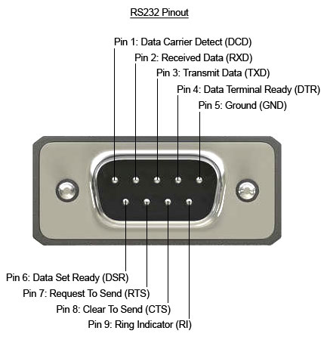2 > 2

3 > 3

5 > 5

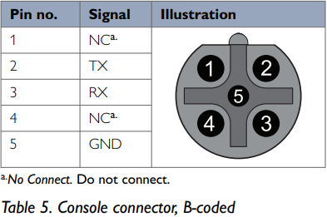

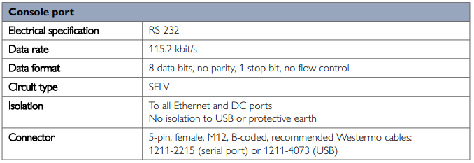

Console Setup

1. Start up Putty64
2. Select serial connection
   1. Select the active com port
3. Select baud rate 115200
4. Select connect
5. When you get a black window you should press enter once, this should bring up the “Login” prompt.
6. The ”admin” password is (”westermo”)

Notes

* The “help” command will show all available commands
* Tab completion is useful for finishing commands
* You cannot tcpdump packets not destined for the port as a destination.

Useful commands

* Show running-config
* Backup
* Ping
* RMON
* Show rmon statistics
* Show rmon statistics (port)
* Show ports
* Show port (port)
* Show Ifaces

7.1.6 Automatic Backup and Restore to/from USB On WeOS units equipped with a USB port, a USB memory stick can be used for automatic backup and restore. The intended application for the auto-backup function is to simplify unit replacement in case of unit failure. Once activated, it works seamlessly. If a stick is already prepared nothing else is needed. If a unit fails you simply replace it, moving the USB stick to the replacement unit. Which must be of same mark and model. At first boot, the replacement unit automatically restores all necessary files from the faulty unit. The auto-backup and restore function only handles configuration. It does not handle backup/restore of WeOS firmware images. You must not only ensure that your replacement unit is of the same model as the original unit. It should also have same WeOS firmware version loaded as the original unit. Note Details of how to activate auto-backup, and how to perform restore are provided in sections 7.1.6.1-7.1.6.2. Section 7.1.6.3 contains information on USB directories for auto-backup and restore. 7.1.6.1 Procedure for activating auto-backup  Basic preparations the USB stick: See section 7.1.5.1 for formatting and partitioning requirement for USB memory sticks used with WeOS units.  Insert USB stick: Insert the USB stick into WeOS unit and power it up.  Log in to CLI: Log into the unit (CLI), either via console port or remotely via SSH (see section 5.2).  Activate auto-backup: Run the CLI ”backup” command. example:/#> backup WeOS Auto Backup & Restore for USB Media =============================================================================== This command initializes a USB media, usually a memory stick, to be used for automatic backup and restore of configuration files (including certificates). Intended use-case is to have one memory stick for each device in the network to ease replacement of faulty units. The replacement WeOS unit will at boot automatically restore the backup and Example © 2022 Westermo Network Technologies AB 113 Westermo OS Management Guide Version 4.32.5-0 seamlessly pick up where the faulty unit left off. Configuration and certificate files, including private keys (!) are backed up to /usb/westermo/backup/ Activate WeOS auto-backup & restore on this USB stick, are you sure (y/N)? y Performing initial backup... Backup done. example/#> The configuration files (including certificates and private keys) are now backed up to sub-directories under ”/usb/westermo/backup/” (see section 7.1.6.3).  Keep USB inserted: The USB memory stick should stay attached to the WeOS unit. Any changes to the configuration files on unit flash will be continuously backed-up to USB. An alternative method to initialise auto-backup is to create the (empty) directory on the USB stick /westermo/backup/ (see section 7.1.6.3) before inserting it to the WeOS unit. Power off the unit and insert the USB stick. When the unit is then powered up, all configuration files (including certificates and private keys) will be backed up on the USB stick automatically. If you instead insert the prepared USB stick into a running unit, files start being backed up at your first (manual) save of the current configuration, e.g., ”cp running startup” from CLI, or upon reboot of the unit. 7.1.6.2 Restoring configuration from USB to replacement unit When booting a WeOS unit checks if a USB stick is attached. If a USB stick is found with auto-backup activated, the WeOS unit checks if a restore operation should take place or not. This automatic restore operation only takes place at boot-up (configuration file is copied from USB to on-board flash, and used as startup configuration), or within an interval of 30 seconds after boot-up. In the latter case, which can occur if the USB stick is not ready at system boot time, the WeOS unit starts with and runs the configuration on on-board flash for a short while; restore operation then updates both the startup-configuration and running configuration. 114 © 2022 Westermo Network Technologies AB Westermo OS Management Guide Version 4.32.5-0 While replacing a WeOS unit using the USB auto-backup and restore support, it is recommended that the unit is disconnected from the network (see step 5 in the procedure below), and therefore there should be no problem if the replacement unit runs with the configuration on the on-board flash for a short while. Still, if it is important that the restore operation takes place before the WeOS reads its startup configuration, an additional boot delay can be added (see section 7.1.2.2 as well as step 1 in the procedure below). Note 1. Prepare replacement unit: The replacement should be of the same model as the original unit (e.g., a Lynx L210-F2G should be replaced by another Lynx L210-F2G), and ensure that it has the same WeOS firmware version loaded as the original unit. If you are unsure of what firmware version your original unit was running, you can inspect the configuration file on your USB stick – at the top of the configuration file used as ”startup-configuration” you should see the WeOS version, e.g., WeOS 4.15.2. Hint It is recommended that the replacement unit has not had the auto-backup feature activated already. If unsure, please do a factory reset11 of the replacement unit before proceeding. Use either of the methods described in section 7.1.3.2 (factory reset via console port), section 7.1.3.3 (cable factory reset), or section 7.2.3 (factory reset via web interface). Optionally, you can then login to the replacement unit and set a USB delay in the boot context. For example, to extend the time to discover a USB stick at boot with up to 10 seconds, use the following commands: example:/#> boot example:/boot/#> usb example:/boot/usb/#> timeout 10 Example 11Only files on unit flash (configuration file(s), IPsec certificates, etc.) will be affected by the factory reset. Files on an attached USB stick (if present) will not be affected. © 2022 Westermo Network Technologies AB 115 Westermo OS Management Guide Version 4.32.5-0 This gives the USB stick more time to settle at boot, and be ready for use when configuration is activated (see remark at the start of this section). Suitable USB delay differs depending on what WeOS product you are using (boot time differs) and what USB stick you are using (see section 7.1.5.1 for information on USB sticks verified for WeOS). 2. Unplug power of replacement unit: Before inserting the USB memory stick holding the backup configuration you should unplug the power of the replacement unit. 3. Insert USB stick in replacement unit 4. Power up the replacement unit: When the replacement unit boots, the configuration files on USB will automatically be restored to unit flash. 5. Connect network cables: It is recommended to connect the network cables after powering up the replacement unit. You may also connect them before powering up the unit (see comments on timings for detecting USB stick at the start of this section). 6. Keep USB attached: The USB memory stick should be stay attached to the WeOS unit. Any changes to the configuration files on unit flash will be continuously backed up to USB. The automatic restore operation is only done when booting the WeOS unit, or within 30 seconds after boot-up12. If the USB stick (holding backup information) is inserted into a running unit need to reboot the unit for the auto-restore operation to occur. Alternatively, you can run the CLI ”restore” command to manually trigger it.

example:

/#> restore Restore backup from USB stick and activate to running-config,

are you sure (y/N)? y

Stopping DHCP/DNS Server

................................... [ OK ] Starting DHCP/DNS Server ...................................

[ OK ] example:/#>